**Install and Setting up Eclipse Spring Tool Suite**

Contents

Part I: Download and install Eclipse Spring Tool Suite 1

Part II: Initialize Eclipse Spring Tool Suite and select workspaces 2

Part III: Install Java for IDE 4

Part IV: Install Maven for IDE 8

Part V: Setting text file encoding for workspace 10

Part VI: Setting Web Server 11

# Part I: Download and install Eclipse Spring Tool Suite

**Step 1:** Create the folder **D:\Dev\STS**

**Step 2**: Go to Eclipse Spring Tool Suite download page at <https://spring.io/tools>

Section Spring Tools 4 for Eclipse, click the button 4.10.0 – Windows 64-Bit

Download file to the folder **D:\Dev\STS**

File name: **spring-tool-suite-4-4.10.0.RELEASE-e4.19.0-win32.win32.x86_64.self-extracting.jar**

**Step 3**: Extract the download file .jar

Open the CMD Windows with administrator permissions

Navigate to the folder **D:\Dev\STS**

Type: **java –jar spring-tool-suite-4-4.10.0.RELEASE-e4.19.0-win32.win32.x86_64.self-extracting.jar**



Extraction process like this:

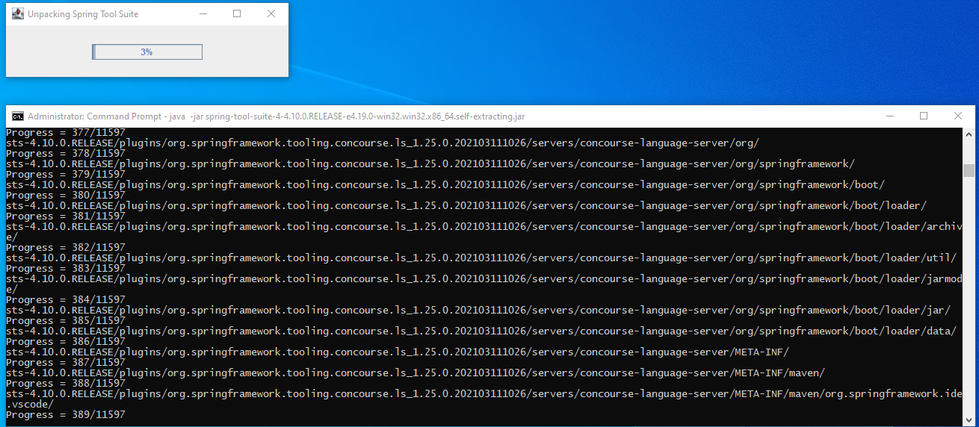

When extracting complete, we get the folder **sts-4.10.0.RELEASE (D:\Dev\STS\** **sts-4.10.0.RELEASE)**

# Part II: Initialize Eclipse Spring Tool Suite and select workspaces

**Step 1**: Create the folder D:\Dev\Workspaces

The folder to store all projects source code.

**Step 2**: Start the Eclipse Spring Tool Suite

Go to: **D:\Dev\STS\ sts-4.10.0.RELEASE\ SpringToolSuite4.exe**

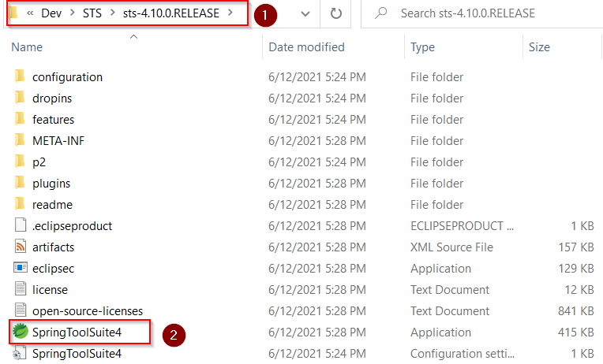

**Step 3**: Choose the Workspaces (**D:\Dev\Workspaces**)

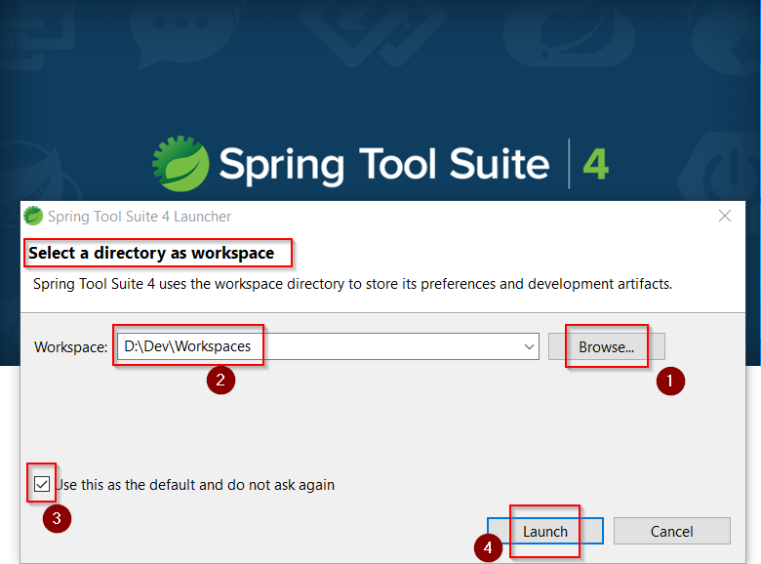

# Part III: Install Java for IDE

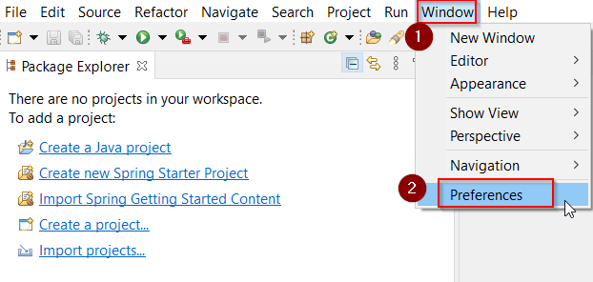

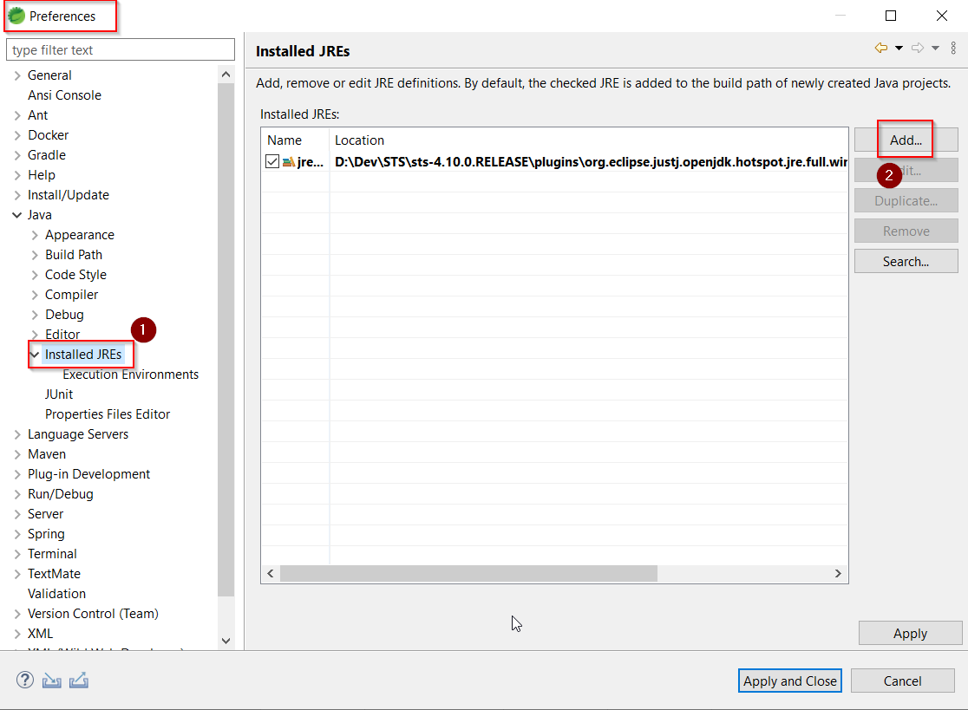

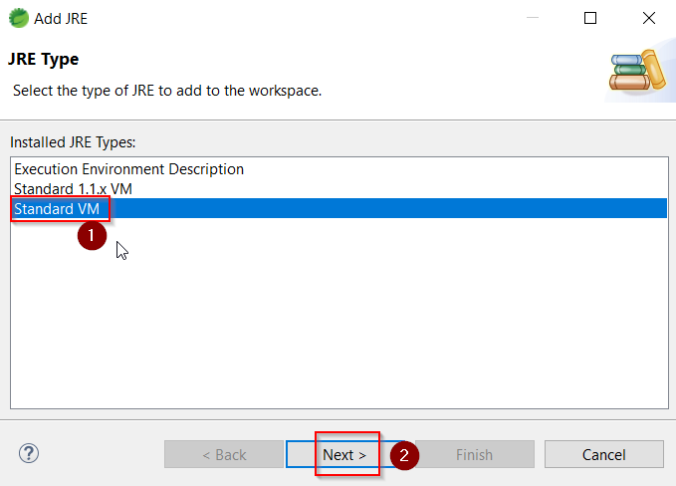

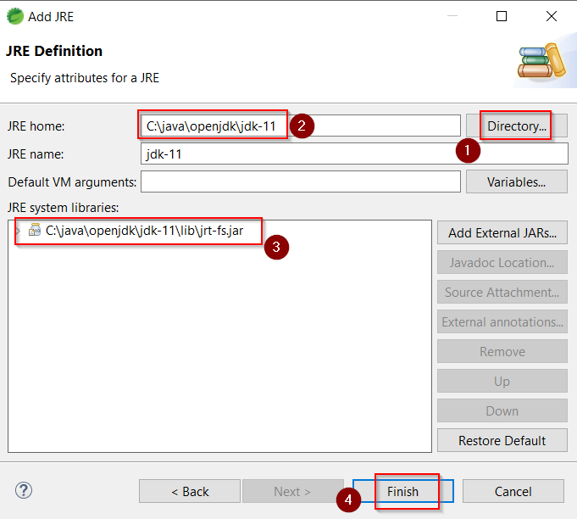

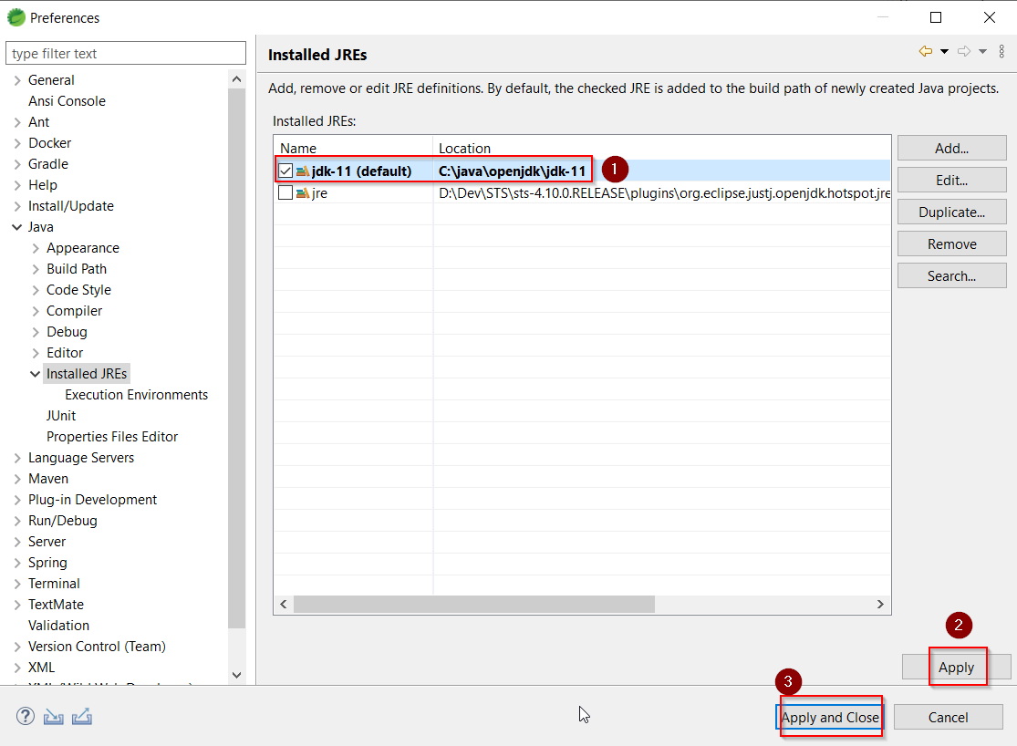

The next step, configure the java compiler to version 11

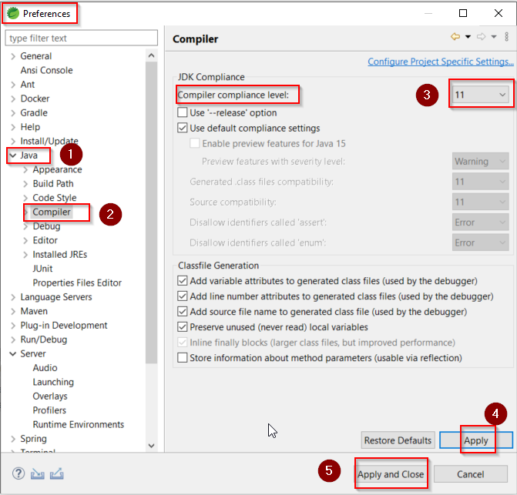

# Part IV: Install Maven for IDE



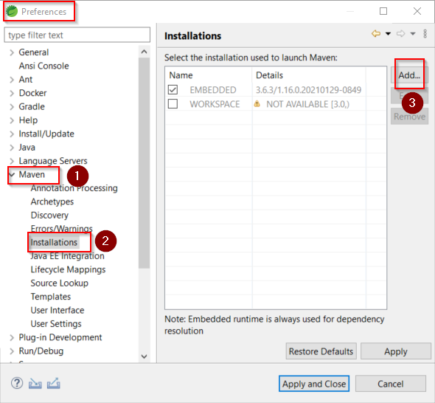

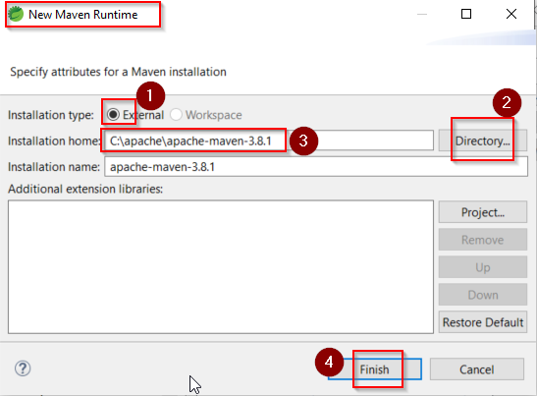

Note: select the maven installed folder: **C:\apache\apache-maven-3.8.1**

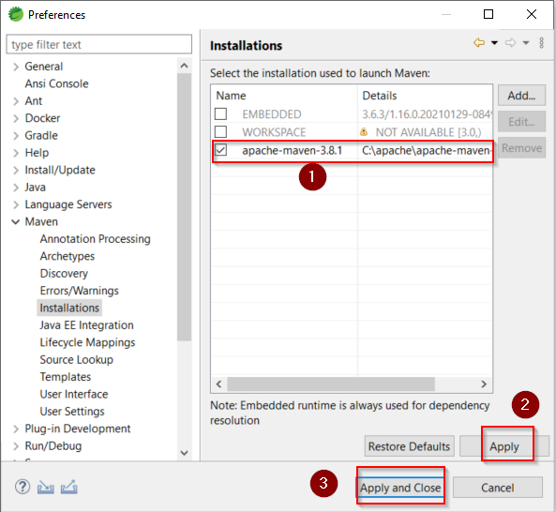

# Part V: Setting text file encoding for workspace



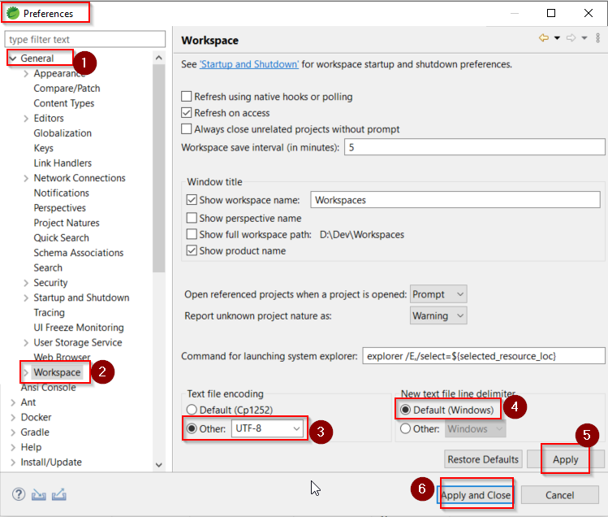

Note: Select text file encoding: **UTF-8**

# Part VI: Setting Web Server



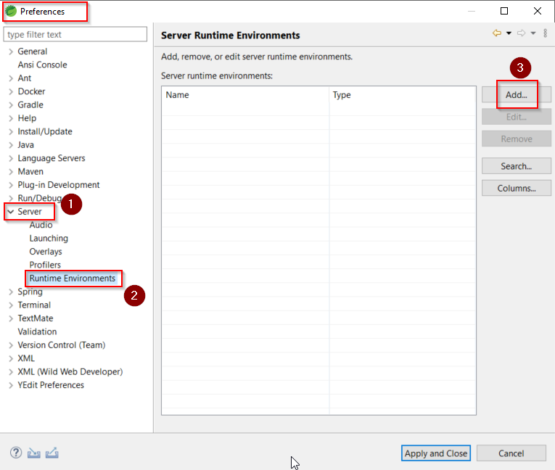

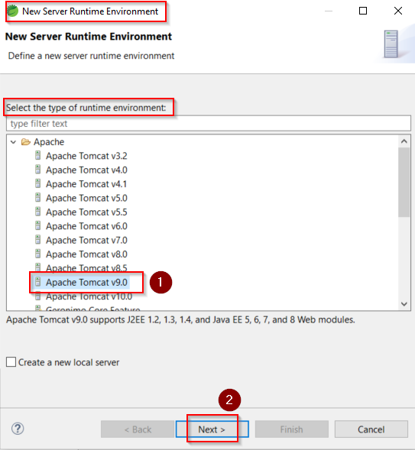

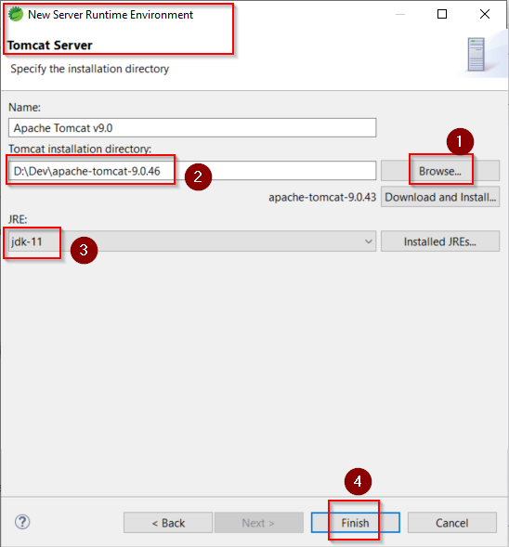

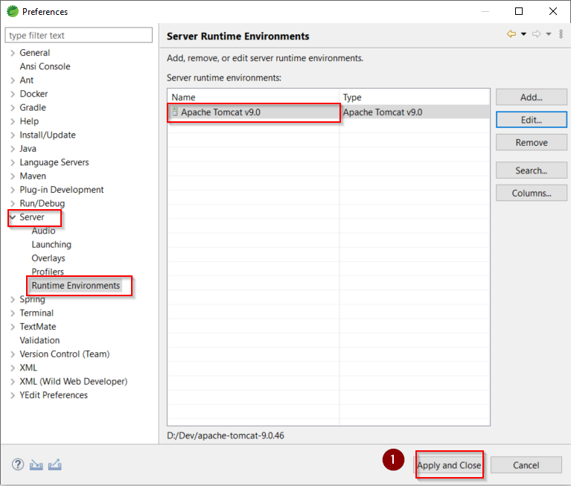

View the server tab

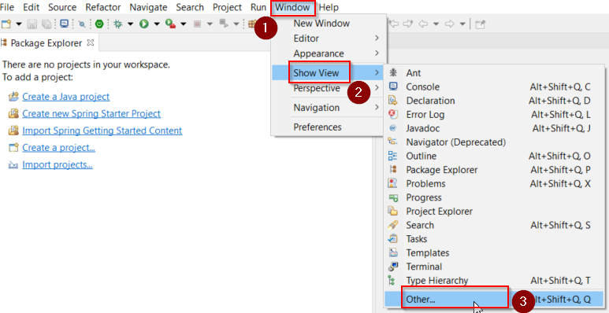

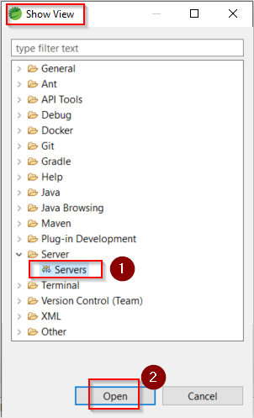

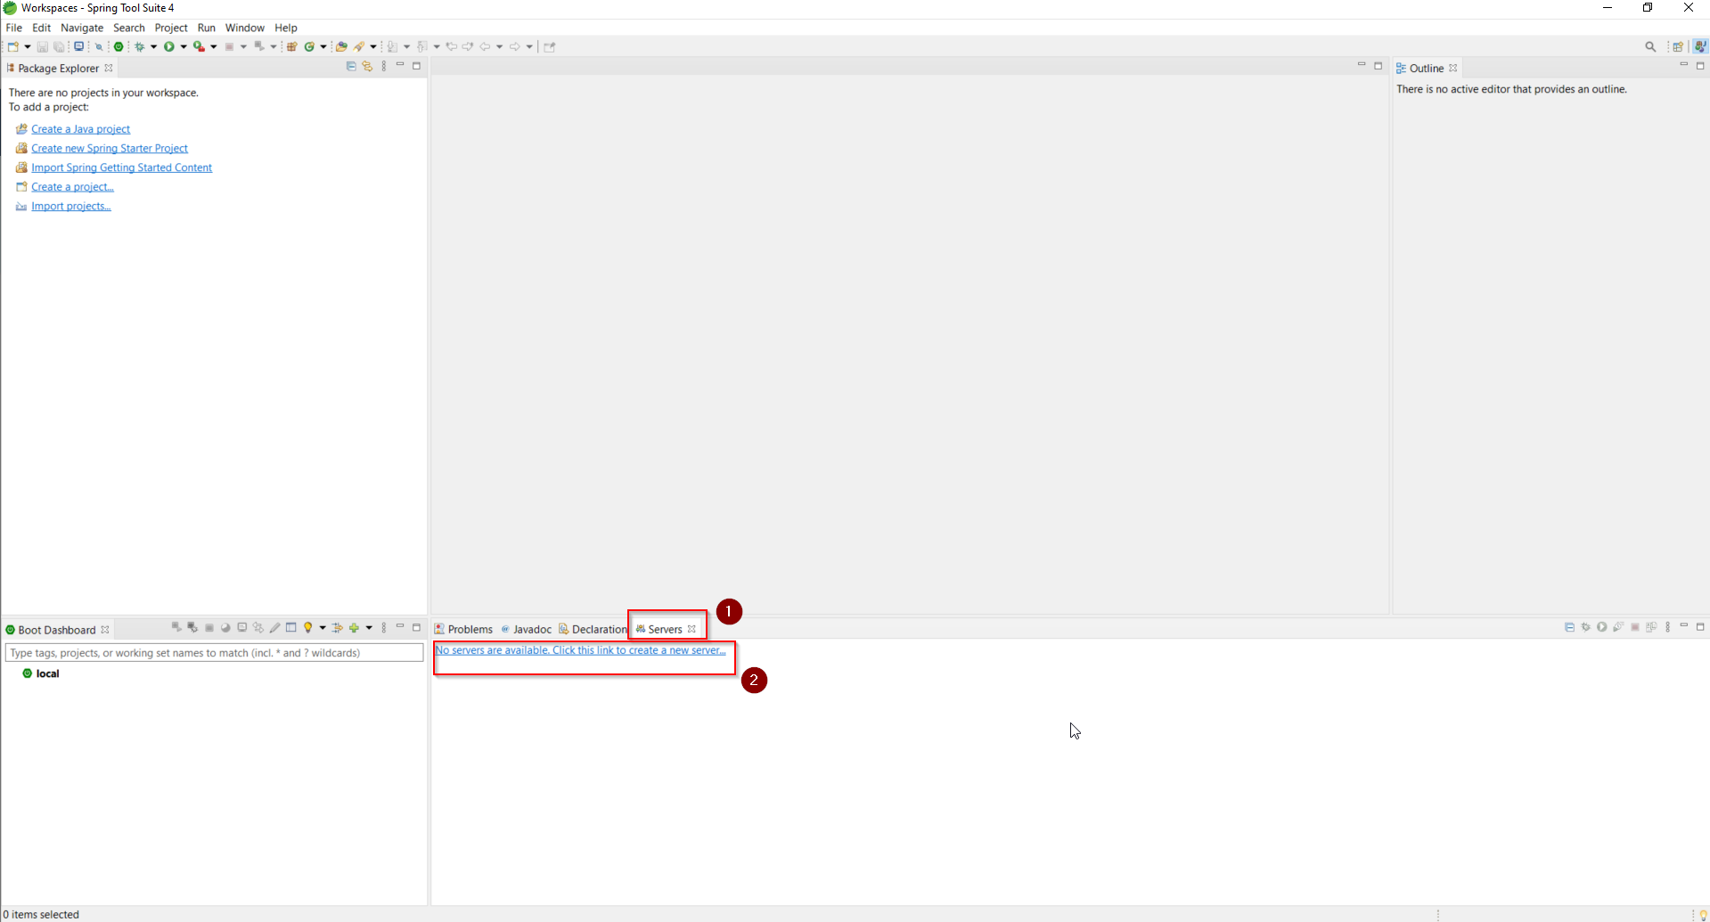

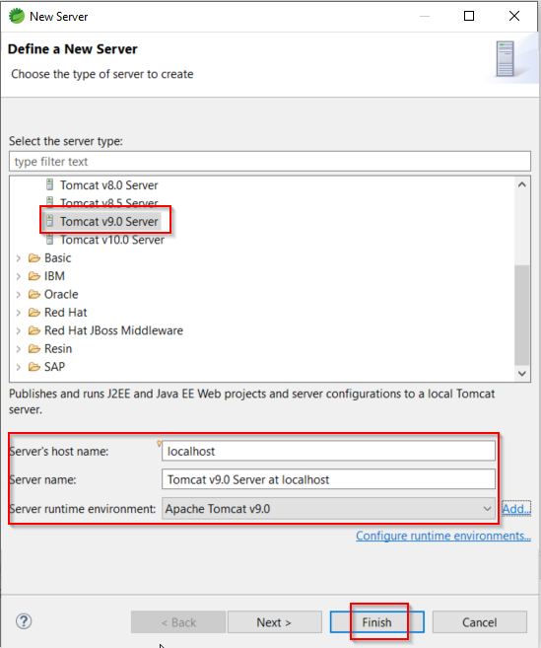

Let get all default value and then click Finish button.

Now, we can control the Tomcat web server from IDE

